10.41: If she had tucked, she would have made 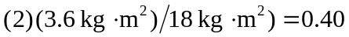 rev in the last 1.0 s, so she would have made 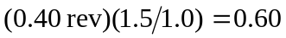 rev in the total 1.5 s.

